logo içeren bir resim

Açıklama otomatik olarak oluşturuldu

**YTU**

**IST2142-DATABASE**

**2022-2023 SPRING GR:2**

**HOMEWORK 2- CREATE A DATABASE MYSQL**

**LECTURER: COSKUN PARIM**

**METIN MIRZA VATANSEVER**

**MEHMET OMER TURK**

**MEHMET DEMIRBILEK**

**AHMET ERDEM CESUR**

**A) (20 pts) Create all your tables and all the attributes related to these tables in MYSQL (with script).**

CREATE TABLE check1 (

Storage_no varchar(45) NOT NULL,

product_id varchar(45) NOT NULL,

**PRIMARY KEY (Storage_no,product_id),**

UNIQUE KEY Storage_no_UNIQUE (Storage_no),

UNIQUE KEY product_id_UNIQUE (product_id),

CONSTRAINT product_id FOREIGN KEY (product_id) REFERENCES products (product_id),

CONSTRAINT Storage_no FOREIGN KEY (Storage_no) REFERENCES storage (Storage_no)

) ENGINE=InnoDB DEFAULT CHARSET=utf8mb4 COLLATE=utf8mb4_0900_ai_ci

CREATE TABLE check2 (

Orders_id varchar(45) NOT NULL,

Storage_no varchar(45) NOT NULL,

**PRIMARY KEY (Orders_id,Storage_no),**

UNIQUE KEY Storage_no_UNIQUE (Storage_no),

UNIQUE KEY Orders_id_UNIQUE (Orders_id),

CONSTRAINT pk2orders_id **FOREIGN KEY (Orders_id)** REFERENCES orders (Orders_id),

CONSTRAINT pk2storage_no **FOREIGN KEY (Storage_no)** REFERENCES storage (Storage_no)

) ENGINE=InnoDB DEFAULT CHARSET=utf8mb4 COLLATE=utf8mb4_0900_ai_ci

CREATE TABLE customer (

Customer_id varchar(45) NOT NULL,

name&surname varchar(45) NOT NULL,

Gender varchar(45) NOT NULL,

adress varchar(45) NOT NULL,

phone_number varchar(45) NOT NULL,

**PRIMARY KEY (Customer_id),**

UNIQUE KEY Customer_id_UNIQUE (Customer_id),

UNIQUE KEY phone_number_UNIQUE (phone_number),

CONSTRAINT check_Gender CHECK (((Gender = _utf8mb4'F') or (Gender = _utf8mb4'M')))

) ENGINE=InnoDB DEFAULT CHARSET=utf8mb4 COLLATE=utf8mb4_0900_ai_ci

CREATE TABLE orders (

Orders_id varchar(45) NOT NULL,

Orders_details varchar(45) NOT NULL,

total_orders varchar(45) NOT NULL,

customer_id varchar(45) NOT NULL,

bill_information varchar(45) NOT NULL,

**PRIMARY KEY (Orders_id),**

UNIQUE KEY Orders_id_UNIQUE (Orders_id),

KEY customer_id_idx (customer_id),

KEY bill_information_idx (bill_information),

CONSTRAINT bill_information **FOREIGN KEY (bill_information)** REFERENCES pay_options (bill_information),

CONSTRAINT customer_id **FOREIGN KEY (customer_id)** REFERENCES customer (Customer_id),

CONSTRAINT check_total_orders CHECK ((total_orders > 0))

) ENGINE=InnoDB DEFAULT CHARSET=utf8mb4 COLLATE=utf8mb4_0900_ai_ci

CREATE TABLE pay_options (

bill_information varchar(45) NOT NULL,

order_options varchar(45) NOT NULL,

order_date varchar(45) NOT NULL,

orders_details varchar(45) NOT NULL,

**PRIMARY KEY (bill_information),**

UNIQUE KEY bill_information_UNIQUE (bill_information),

CONSTRAINT check_order_options CHECK (((order_options = _utf8mb4'Credit Card') or (0 <> _utf8mb4'Cash')))

) ENGINE=InnoDB DEFAULT CHARSET=utf8mb4 COLLATE=utf8mb4_0900_ai_ci

CREATE TABLE products (

product_id varchar(45) NOT NULL,

Colour varchar(45) NOT NULL,

Size varchar(45) NOT NULL,

Type varchar(45) NOT NULL,

**PRIMARY KEY (product_id),**

UNIQUE KEY product_id_UNIQUE (product_id),

CONSTRAINT check_Colour CHECK (((Colour = _utf8mb4'Black') or (0 <> _utf8mb4'White') or (0 <> _utf8mb4'Yellow') or (0 <> _utf8mb4'Blue'))),

CONSTRAINT check_products CHECK (((Size = _utf8mb4'Small') or (0 <> _utf8mb4'Medium') or (0 <> _utf8mb4'Large'))),

CONSTRAINT check_size CHECK (((Size = _utf8mb4'Small') or (0 <> _utf8mb4'Medium') or (0 <> _utf8mb4'Large')))

) ENGINE=InnoDB DEFAULT CHARSET=utf8mb4 COLLATE=utf8mb4_0900_ai_ci

CREATE TABLE storage (

Storage_no varchar(45) NOT NULL,

Amount varchar(45) NOT NULL,

Row&shelf number varchar(45) NOT NULL,

**PRIMARY KEY (Storage_no),**

UNIQUE KEY Storage_no_UNIQUE (Storage_no)

) ENGINE=InnoDB DEFAULT CHARSET=utf8mb4 COLLATE=utf8mb4_0900_ai_ci

**B) (20 pts) Define the restrictions for the attributes (with script).**

**Gender Choice Customers**

ALTER TABLE ödev1.customer

ADD CONSTRAINT check_Gender CHECK

(Gender = "F" OR Gender = "M") enforced ;

**Your Shopping Cart Must Contain At Least One Product**

ALTER TABLE ödev1.orders

ADD CONSTRAINT check_total_orders CHECK

(total_orders > 0) enforced;

**Payment Method**

ALTER TABLE ödev1.pay_options ADD CONSTRAINT check_order_options CHECK

(order_options = "Credit Card" OR "Cash" ) enforced;

**Product Features**

ALTER TABLE ödev1.products ADD CONSTRAINT check_size CHECK

(size = "Small" OR "Medium" OR "Large") enforced;

ALTER TABLE ödev1.products ADD CONSTRAINT check_Colour CHECK

(Colour = "Black" OR "White" OR "Yellow" OR "Blue") enforced;

**C) (20 pts) Define primary keys (with script)**

**We have done this in A, you can see the codes with bold letter.**

**D) (20 pts) Define foreign keys and relate the tables with each other (with script)**

metin içeren bir resim

Açıklama otomatik olarak oluşturuldumetin içeren bir resim

Açıklama otomatik olarak oluşturuldu

metin içeren bir resim

Açıklama otomatik olarak oluşturuldu

metin içeren bir resim

Açıklama otomatik olarak oluşturuldu

metin içeren bir resim

Açıklama otomatik olarak oluşturuldu

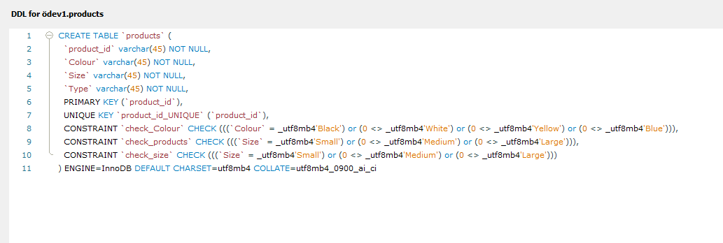

metin içeren bir resim

Açıklama otomatik olarak oluşturuldu

metin içeren bir resim

Açıklama otomatik olarak oluşturuldu

metin içeren bir resim

Açıklama otomatik olarak oluşturuldu

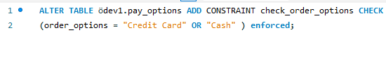

metin içeren bir resim

Açıklama otomatik olarak oluşturuldu

**E) (20 pts) Draw the schema of your ER model with reverse engineering (without script).**

diyagram içeren bir resim

Açıklama otomatik olarak oluşturuldu